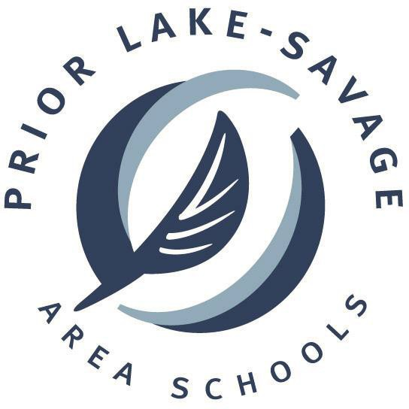
Department of Operations/ Transportation/Health and Safety

To: ISD #719 Staff
From: Jim Dellwo
Date: Spring 2022
Re: Pesticide* Estimated Application Schedule for the 2022-2023 School Year

Per the “Parents Right to Know Act” that took effect on September 15, 2000, we are required to keep a schedule of pesticides* for anyone who might want to know when an application will be performed. This schedule must also be stored for a period of 6 years.

Estimated application schedule for 2022-2023 school year:

- Summer Break
- October 19-21, 2022 (MEA Break)

Pesticide List:

To see a list of possible pesticides* that could be used in the district buildings or on the district grounds, please contact Jim Dellwo @ (612) 226-0054 or jdellwo@plsas.org

*’Pesticides’ definition per Parents Right-to-Know Act: herbicides, insecticides, fungicides, fertilizers in EPA toxicity class I, II, or III

